# Selecting Microprocessor for Coriandolo Radio

* Craig Goldman, 2017-10-09

Coriandolo Radio now supports two microprocessors – the nRF51822 CortexM0 processor and the nRF52840 Cortex M4 processor.

To use the Keil tools to program one of these processors, make sure the Nordic Semiconductor Pack is downloaded using the Keil “PackInstaller”.

## Selecting nRF51 microprocessor

In the Keil project, right-click on the named target and select Options for Target <name>…. Select the “Device” tab (on the far left)

Under Nordic Semiconductor, under nRF51 Series, select nRF51822_xxAA. This will set the defined constants you need as part of the compile and link.

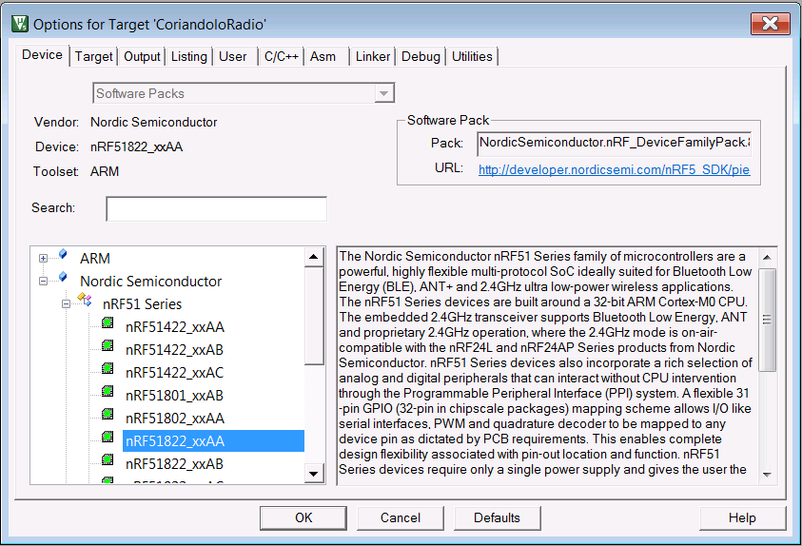

In the Coriandolo Radio project, in the Core file folder, you will need to include the two nRF51 files -- "arm_startup_nrf51.s" and "system_nrf1.c".

You only need “nRF51_RadioHW.c”, but it is OK if “nRF52_RadioHW.c” is included in the project. The nRF52 code will be conditionally compiled out.

Make sure you include only one file that contains “main()”. In the example below that file is “SpeedTest_CR.c”

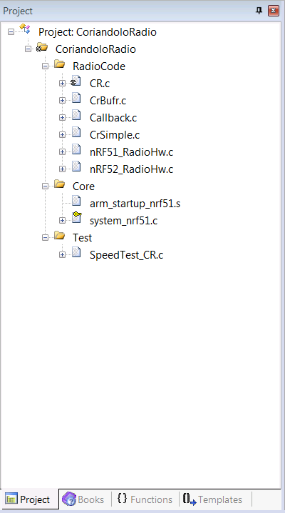

## Selecting nRF52 microprocessor

In the Keil project, right-click on the named target and select Options for Target <name>…. Select the “Device” tab (on the far left)

Under Nordic Semiconductor, under nRF52 Series, select nRF52840_xxAA. This will set the defined constants you need as part of the compile and link.

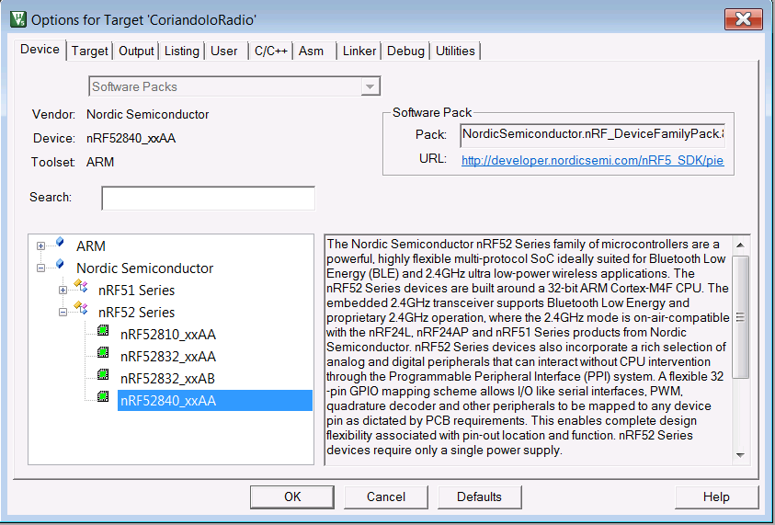

In the Coriandolo Radio project, in the Core file folder, you will need to include the two nRF52 files -- "arm_startup_nrf52840.s" and "system_nrf52840.c".

You only need “nRF52_RadioHW.c”, but it is OK if “nRF51_RadioHW.c” is included in the project. The nRF51 code will be conditionally compiled out.

Make sure you include only one file that contains “main()”. In the example below that file is “RadioTest_CR.c”

